Archimedes’ Principle

Equipment

|  |  |  |
| --- | --- | --- |
| 1 | Force Sensor | PS-2189 |
| 1 | Density Set | ME-8569 |
| 1 | Braided String | SE-8050 |
| 1 | 90 cm Rod | ME-8738 |
| 1 | 45 cm Rod | ME-8736 |
| 1 | Multi-Clamp | ME-9507 |
| 1 | Large Rod Base | ME-8735 |
|  | Required but not included: |  |
| 1 | Calipers | SE-8710 |
| 1 | 1000 ml Beaker | SE-7288 |

Introduction

Archimedes' Principle states: "When an object is submerged in a fluid, the fluid exerts an upwards buoyant force equal to the weight of the fluid displaced by the object".

In this lab, the buoyant force on an object is measured by taking the difference between the object's weight in air, and its apparent weight in water. This measured buoyant force is compared to the theoretical value calculated using the object's volume, and Archimedes' Principle.

Several objects of different shapes are examined: Some of the objects have the same density, some have the same volume, and some have the same mass. The dependence of the buoyant force on density, mass, volume and shape is explored.

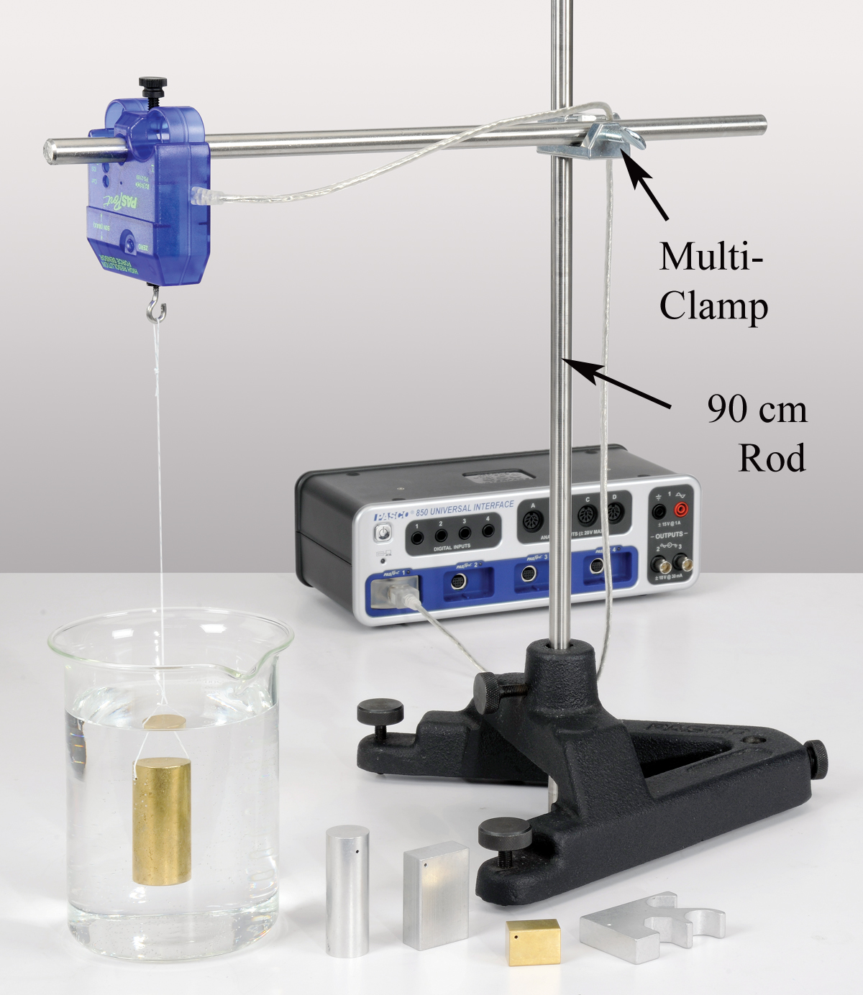

Setup

Figure 1: Measuring the Buoyant Force

When an object is submerged in a fluid, the apparent weight of the object is less than the weight in air because of the upward buoyant force. Thus the buoyant force can be calculated by finding the difference between the weight of the object in air and the apparent weight of the object when it is submerged in water.

1. Use the base, rods and multi-clamp to support the Force Sensor over the beaker as shown in Figure 1.
2. Plug in the sensor. Zero the sensor.
3. Tie a piece of string onto each of the masses. Tie a loop on the other end of the string so that it can be hooked onto the sensor.
4. Put 1000 ml of water in the beaker, but don't submerge the samples yet!
5. In PASCO Capstone, set the sample rate to 500 Hz. Change the Sampling Mode to Fast Monitor.
6. Create a table as shown below. Create a User-Entered Data set called “Object” and fill in the types of objects. Create User-Entered Data sets called “W air” (Weight in air) and “W water” (Weight in water), both with units of N. The last column contains a calculation.

Table I: Buoyant Force = Weight in Air – Weight in Water

|  |  |  |  |
| --- | --- | --- | --- |
| Object | W air  (N) | W water  (N) | Wair – Wwater  (N) |
| Brass Cylinder |  |  |  |
| Aluminum Cylinder |  |  |  |
| Brass Cube |  |  |  |
| Aluminum Cube |  |  |  |
| Aluminum Shape |  |  |  |

In the Capstone calculator, create the following calculations:

‎Wair - Wwater‎ = [W air (N)‎]-[W water (N)‎] with units of N

‎Weight ‎= abs(avgfilter(100,[Force (N)‎])) with units of N

‎Buoyant Force ‎= ρ*[Volume (cc)‎]*g/1000 with units of N

‎ ρ‎ = 1.00 with units of g/cm3

‎ g‎ = 9.81 with units of m/s2

1. Create a Digits display with the calculation “Weight”.

Procedure: Using Weight

1. With nothing hanging on the Force Sensor, click on Monitor. Note the weight being shown in the digits display.
2. Hang the brass cylinder on the Force Sensor with the beaker moved out of the way, so that the sample hangs in air.
3. Record the weight in the "W air" column of Table I.

Note that you don't need to start and stop recording. The program is in "Monitor" mode, where it continually updates the display, but doesn't actually record any data.

1. Move the beaker with water under the Force Sensor, and hang the sample completely submerged as shown in Figure 1. Adjust the height if necessary.
2. Record the weight in the "W water" column. Note that the buoyant force = "weight in air - weight in water" is automatically calculated in the last column.
3. Repeat for the other listed samples, including the irregularly shaped aluminum piece. Always check to make sure that the weight reads zero with the sample removed, and that the sample is completely submerged but not touching the bottom when measuring in water.
4. When you have made all your measurements, click on Stop.

Procedure: Using Volume

1. Create a table as shown below. Select “Object” in the first column. Create a User-Entered Data set called “Volume” with units of cc. Select the calculation “Buoyant Force” in the third column.

Table II: Buoyant Force = Weight of Fluid Displaced

|  |  |  |
| --- | --- | --- |
| Object | Volume  (cc) | Buoyant Force  (N) |
| Brass Cylinder |  |  |
| Aluminum Cylinder |  |  |
| Brass Cube |  |  |
| Aluminum Cube |  |  |
| Aluminum Shape |  |  |

1. Use calipers to measure the radius and height of the brass cylinder, and record your measurements.
2. Calculate the volume of the cylinder and record the value in Table II.
3. Note that the Buoyant Force = "weight of water displaced" is automatically calculated in the last column. Calculate the value yourself to confirm that it is correct. Pay attention to the units! Remember that the relationship between mass (m), density (ρ) and volume (V) is

m = ρV

Hint: To calculate the weight of water displaced, you must use the density of water!

ρwater = 1.00 g/cc

Finally, remember that the buoyant force is the weight of the displaced fluid, not just the mass. You can look at the equation used in the Calculator for help.

1. Use calipers to measure the dimensions of the other samples and record their volumes in the table. To calculate the volume of the irregularly shaped object, use its weight and assume it has the same density as the other aluminum shapes.

Analysis

1. Create a table as shown below. Select “Object” in the first column, “Wair – Wwater” in the second column, and “Buoyant Force” in the third column. Create a User-Entered Data set called “% Difference” in the fourth column.

Table III: Weight Method vs. Volume Method

|  |  |  |  |
| --- | --- | --- | --- |
| Object | Wair – Wwater  (N) | Buoyant Force  (N) | % Difference |
| Brass Cylinder |  |  |  |
| Aluminum Cylinder |  |  |  |
| Brass Cube |  |  |  |
| Aluminum Cube |  |  |  |
| Aluminum Shape |  |  |  |

1. Table III shows the results for the buoyant force calculated using the apparent weight (weighing method) and directly using Archimedes' Principle (volume method). What do you conclude?
2. Calculate the % difference for each sample.
3. Which other samples have approximately the same volume as the aluminum cylinder. How do their values for the buoyant force compare? Explain how this can be, even when the other sample doesn't have the same mass, density, size or shape?
4. If you re-did this experiment with the brass mass only half submerged, what would change? Would the "weight method" still give you the same answer for the buoyant force as the "volume method"? Try it!
5. The plastic cylinder that comes with the Density Set floats in water. What does it tell you about its density? What is its apparent weight when floating? What is the buoyant force acting on it while floating? What would be the buoyant force if it was completely submerged?
6. If you added salt to the water in the beaker, it would change its density. How could you use the apparent weight of the brass cylinder hanging in the salt water to find this new density? Try it!